|  |
| --- |
| Embedded Systems Lab Experiment 8 |
| Pulse Width Modulation using ATMega 32 microcontroller |
| To program ATMega 32 microcontroller to accept multiple analogue inputs and mux among them and using the digital value to control the led brightness by PWM technique |

|  |
| --- |
| Jitbitan Baroi  3-17-2024 |

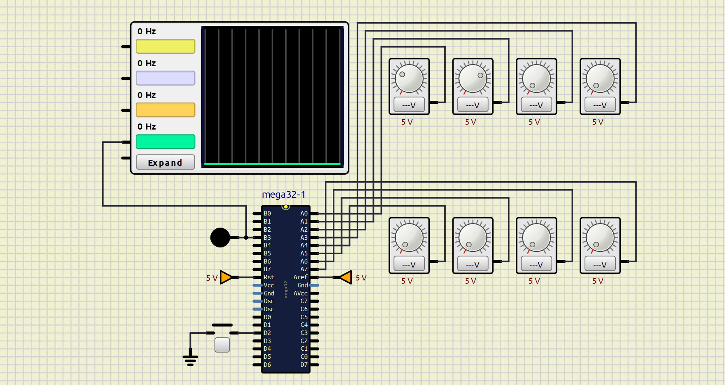

Schematic used for mux multiples analog inputs at Pin A and controlling the brightness of the LED using one analog input at a time and the PWM signal is shown in the oscilloscope

|  |
| --- |
|  |
|  |

Two different analog voltage levels from variable voltage source 1 are given and the corresponding brightness of the LED as well as the PWN signal is shown

|  |
| --- |
|  |
|  |

Two different analog voltage levels from variable voltage source 1 are given and the corresponding brightness of the LED as well as the PWN signal is shown control is switched from variable voltage source 1 to 2 by push button